* Use the correct URL listed above in the Reading List to test the connection:
  + 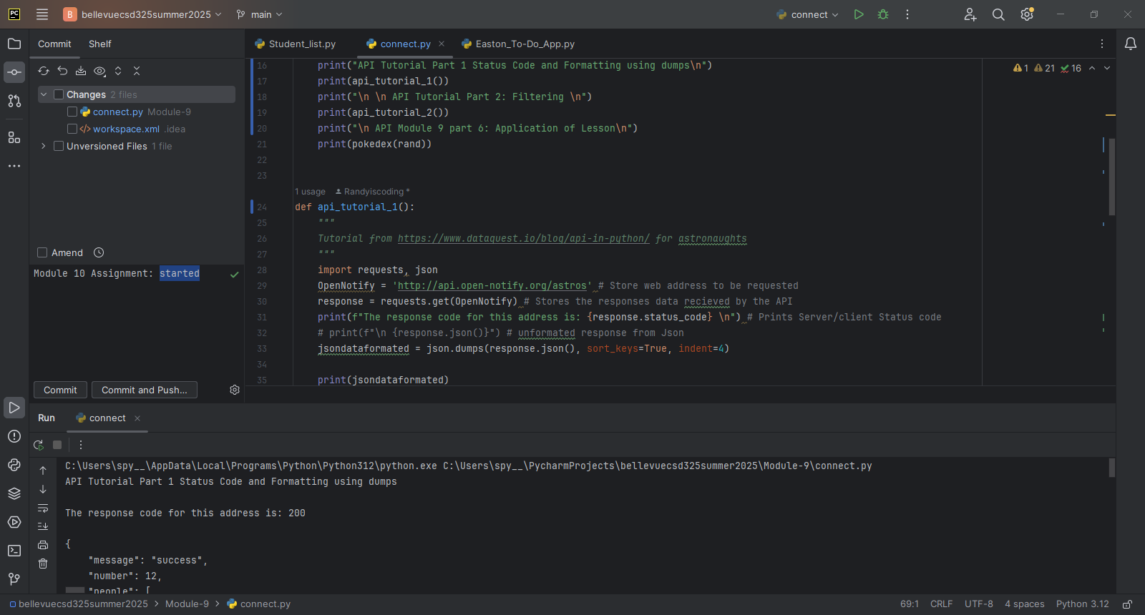
* Complete the section in the tutorial for retrieving current astronauts and formatting output. Incorporate that code into your program, run the program and take a screenshot of the results and paste into the Word document.
  + 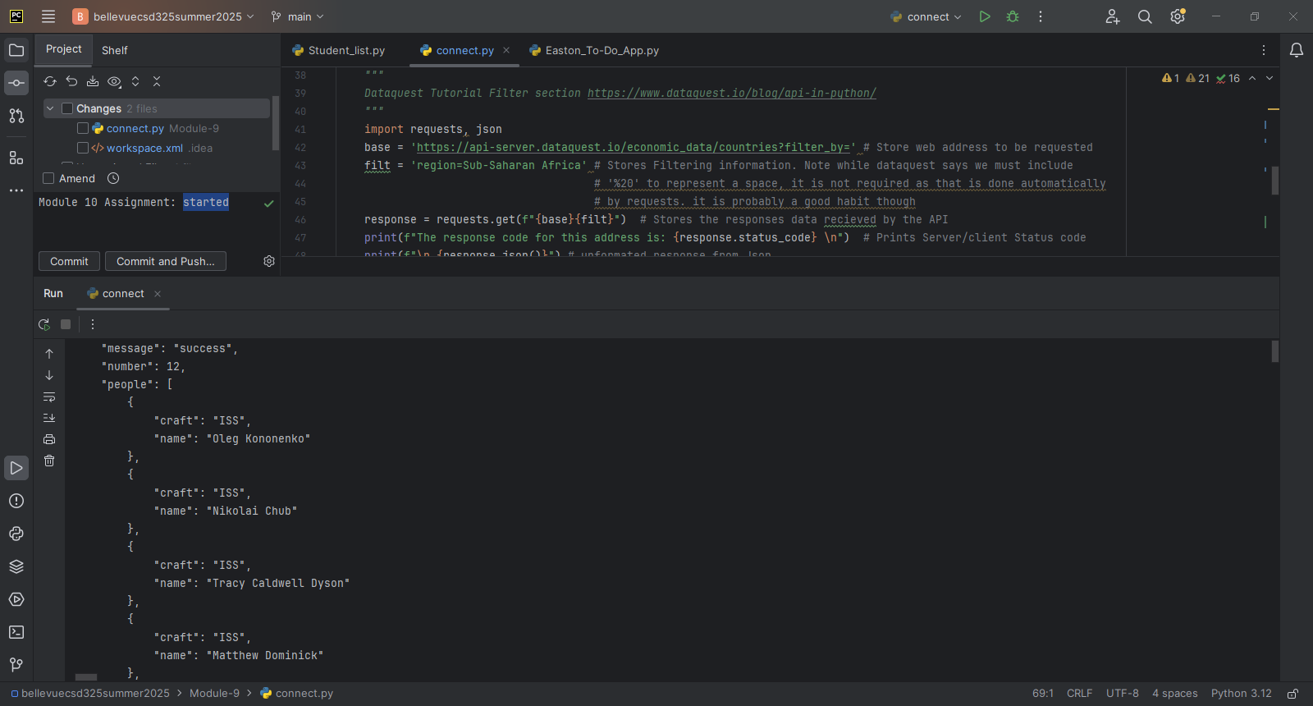
* Create a program that includes the following:
  + Find a simple API. The link above has a couple that you can work with, but the examples are not in Python...the concept is the same..
  + Test the connection to your API, output results.
  + Print out the response from the request, with no formatting.
  + Print out the response with same formatting as the tutorial program.
  + Run the program and take a screenshot of the results. Paste that screenshot into your Word document.
    - 